BÀI TẬP 3 MÔN KĨ THUẬT LẬP TRÌNH
Exercise 1: Rewrite your pay computation to give the employee 1.5 times the hourly rate for hours worked above 40 hours.
Enter Hours: 45
Enter Rate: 10
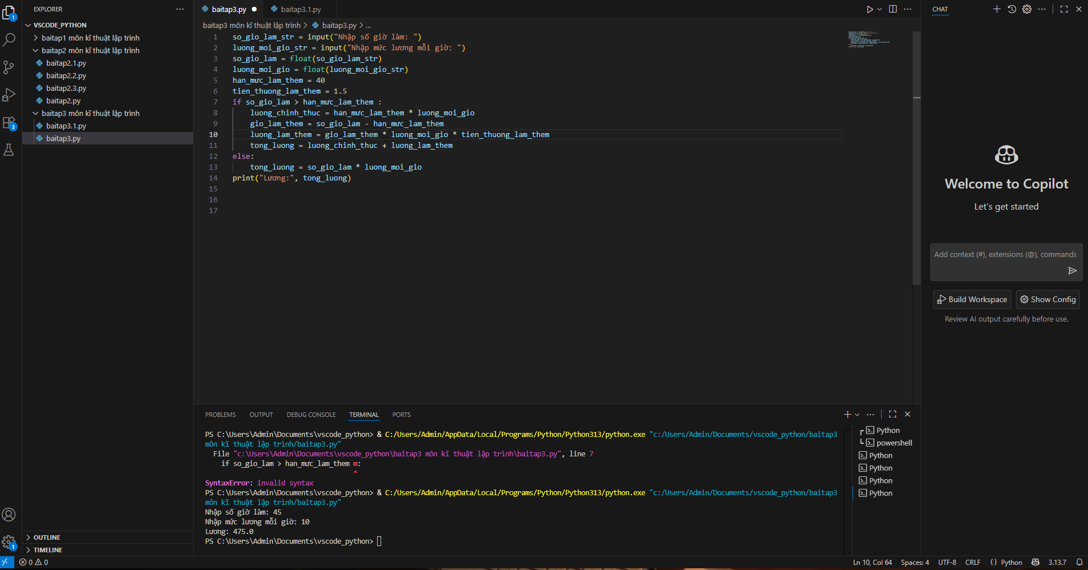
Pay: 475.0

Exercise 2: Rewrite your pay program using try and except so that your pro gram handles non-numeric input gracefully by printing a message and exiting the program. The following shows two executions of the program:
Enter Hours: 20
Enter Rate: nine
Error, please enter numeric input
Enter Hours: forty Error, please enter numeric input

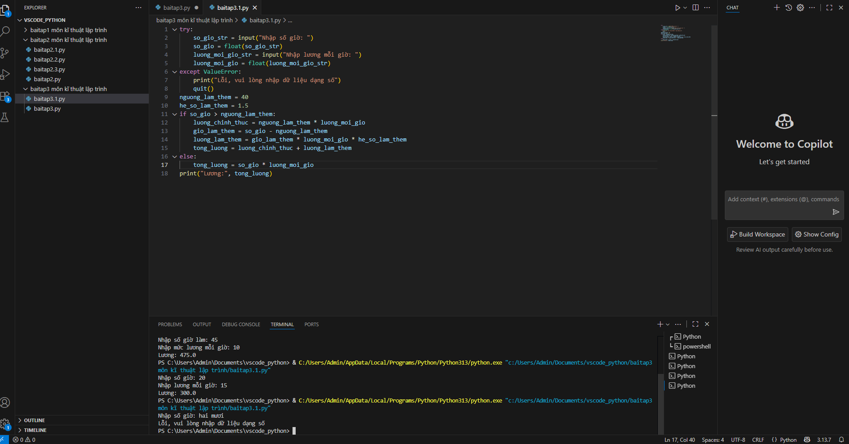
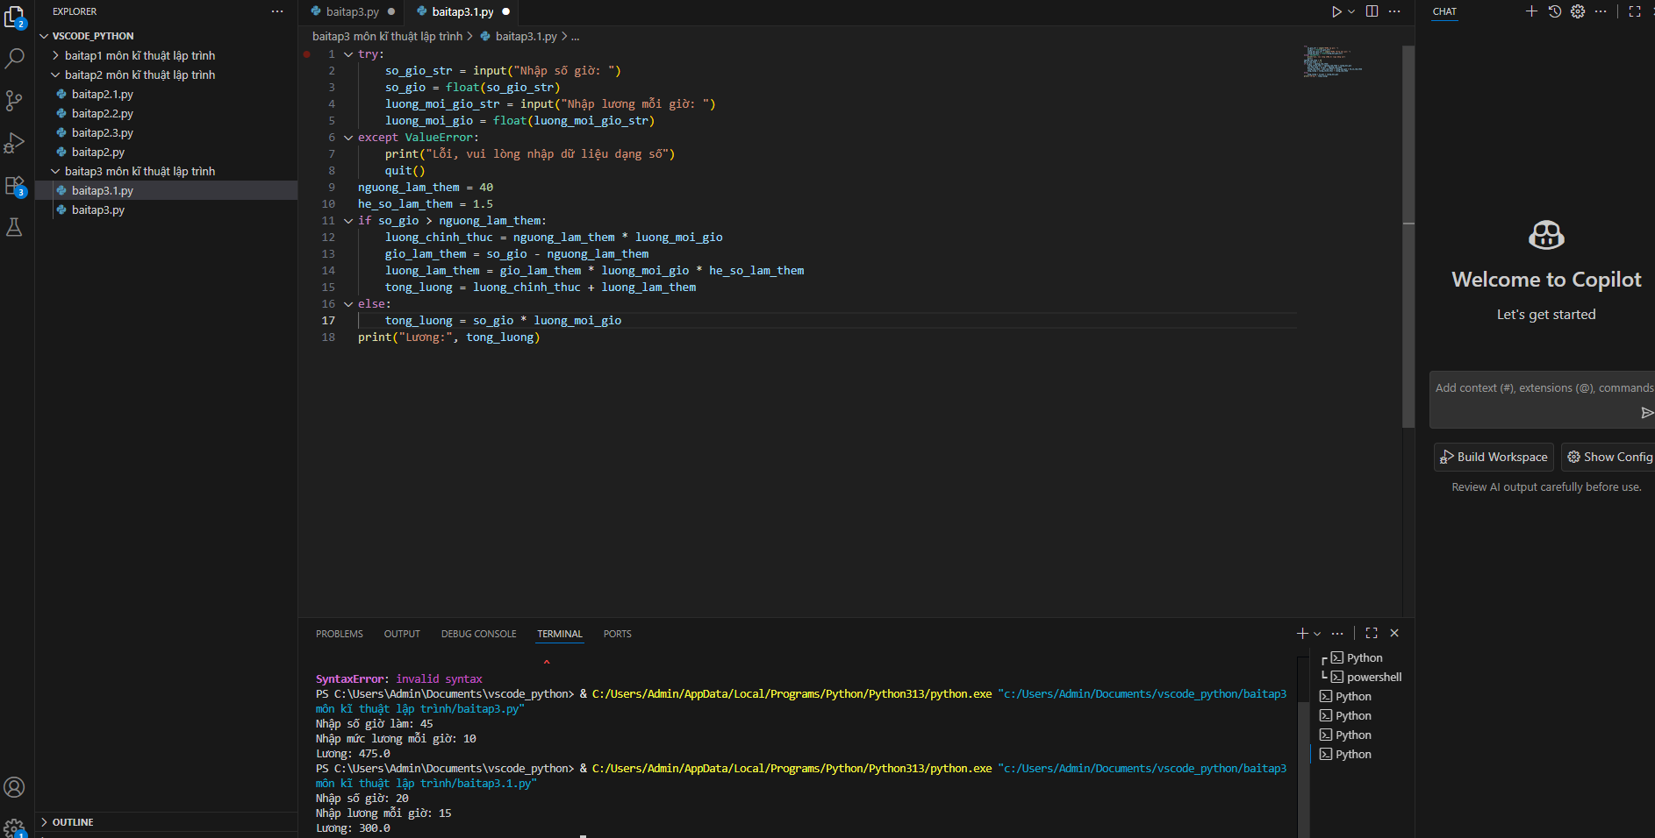

Exercise 3: Write a program to prompt for a score between 0.0 and 1.0. If the score is out of range, print an error message. If the score is between 0.0 and 1.0, print a grade using the following table:
Score Grade
>= 0.9 A
>= 0.8 B
>= 0.7 C
>= 0.6 D
< 0.6 F
Enter score: 0.95 A
Enter score: perfect
Bad score
Enter score: 10.0
Bad score
Enter score: 0.75 C
Enter score: 0.5 F
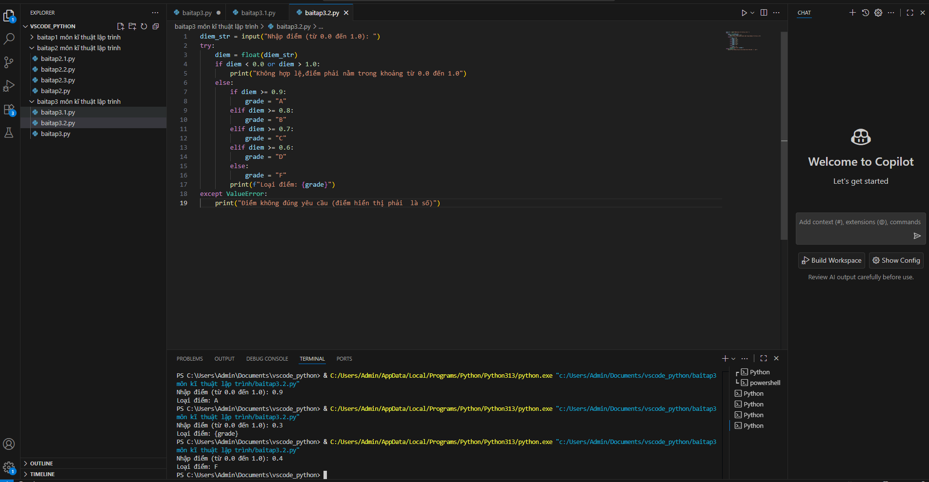
Run the program repeatedly as shown above to test the various different values for input

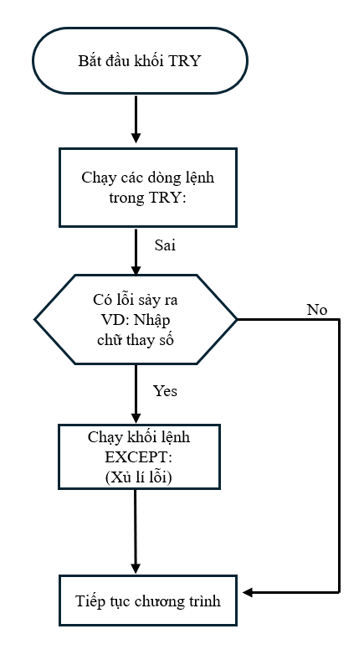
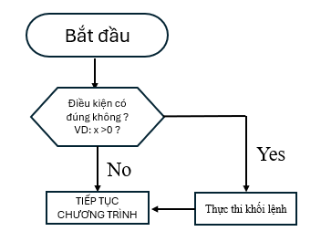
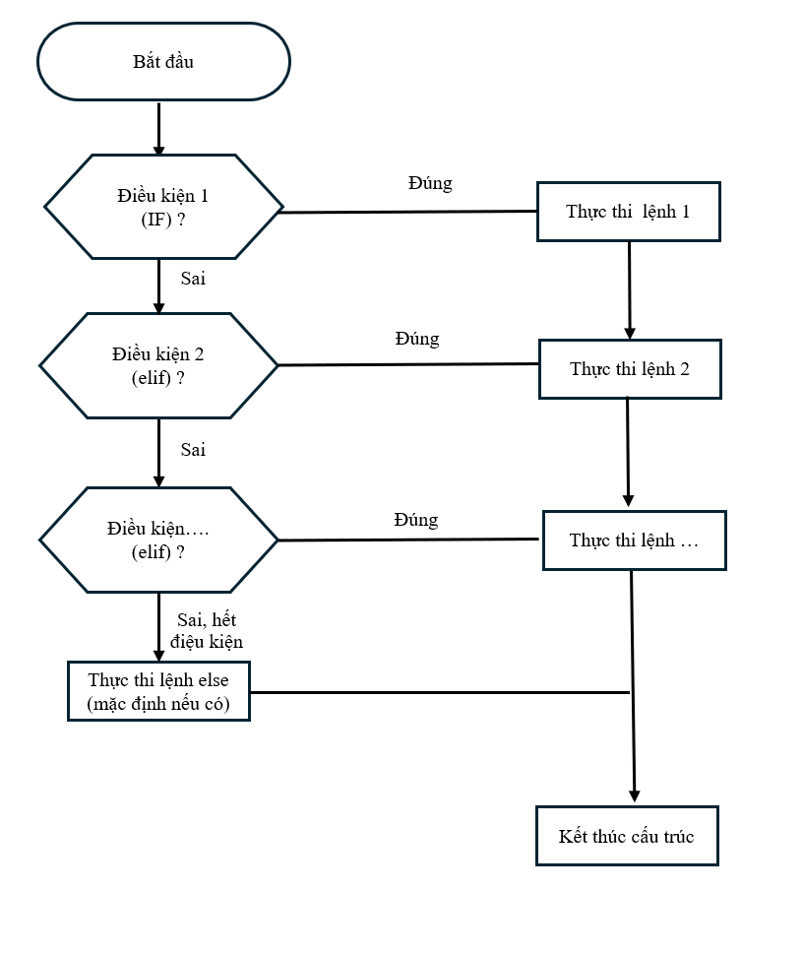
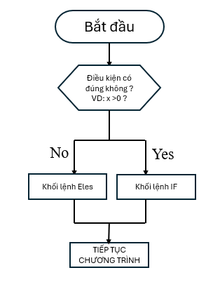
LƯU ĐỒ G IẢI THUẬT BÀI TẬP 3 MÔN LẬP TRÌ NH

